Will Marty Make it Back to the Future?
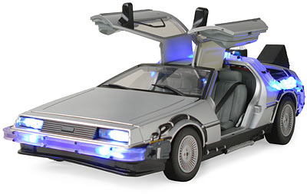

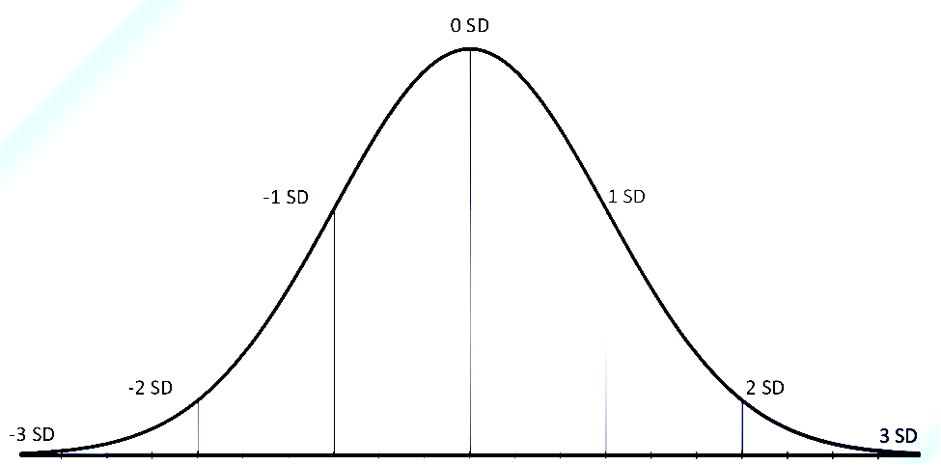
After accelerating for 20 seconds, a DeLorean sports car has a wide range of speeds that it can achieve, depending on traction. The distribution of speed follows an approximately Normal distribution with a mean of 80 mph and a standard deviation of 7.7 mph.

1. Label the appropriate values
on the normal distribution

2. What percentage of the runs will give the Delorean a speed greater than 87.7 mph?

3. What percentage of the runs will give the Delorean a speed between 64.6 mph and 87.7 mph?

4. What percentage of the runs will give the Delorean a speed less than 64.6 mph?

5. What percentage of the runs will give the Delorean a speed less than 68.45 mph?

6. What percentage of the runs will give the Delorean a speed greater than 85 mph? Show work.

7. What percentage of the runs will give the Delorean a speed between 70 and 95 mph? Show work.

8. Marty wants his last run to be in the top 15% of all the possible speeds. What speed does he need to achieve to be in the top 15%?

Density Curves and Normal Distributions
Important Ideas:
Check Your Understanding:

According to an article at africageographic.com there are many unexpected uses for elephant waste. But how much waste do elephants produce per day? Studies show that the distribution of amount of waste produced by adult elephants can be modeled by a Normal distribution with mean 250 pounds and standard deviation 21 pounds.
a. What percent of adult elephants produce at least 300 pounds of waste in a day?

b. A zoo has an agreement with the local farmers. They sell the daily waste from their elephant to the farmers for $5.00 per pound. If the amount of waste produced by the elephant on a given day is at the 10th percentile of the distribution of waste, how much money would the zoo make selling the waste that day?

