What was the average for the Chapter 6 test?
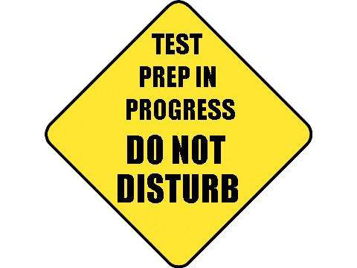

How did the Chapter 6 test go? Today, we will be taking a sample from a population. We will use the average from the sample to estimate the average for the population.

Let’s start with a very simple example. My 5th hour is very small. There were only 4 students who took the chapter 6 test. Their scores were: 60 70 80 90.

- Make a dotplot of the population distribution.

- Take a sample of any 2 of the scores. Find the mean of your sample.

- Figure out all of the possible samples of size 2. Calculate a sample mean for each sample of 2.

- Make a dotplot using each of the means you found in #3.

- What is the mean of the population? Label this on the dotplot above.

What is a Sampling Distribution? Day 1
Important ideas:

Check Your Understanding

The James family has five children: Jocelyn (age 8), Alyse (age 8), Michael (age 14), Erica (age 16), and Sarah (age 18).

- Complete the table by listing the 10 possible samples of size n = 2 from this population and calculate the sample mean age for each sample. The first column is completed for you.
Sample  n = 2 | J, A
 | 8

- Create a sampling distribution of the sample mean age of samples of size 2.

- What is the mean of the sampling distribution of the sample mean? What is the mean of the population?

- Is the sample mean an unbiased estimator of the population mean? Justify your answer.

- Suppose we had taken samples of size 3 instead of size 2. Would the variability of the sampling distribution of the sample mean be larger, smaller, or about the same? Justify your answer.

