What is wrong with these surveys?
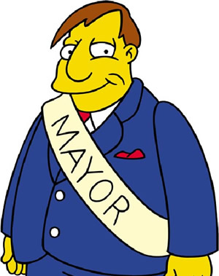

Identify what is wrong in each of these surveys. Be sure to explain.

1. The mayor of Springfield is interested in finding out the average age of people in the city. He obtains a list of all of the landline telephones in the city, and then contacts a simple random sample of 300 people. He uses the data from the sample to estimate the average age of all the people in the city.
- What is wrong with this survey?

- Do you think the Mayor will over or underestimate the true mean age of people in Springfield? Why?

2. The administration at a school wants to know the proportion of students that did all of their homework last night. They select a simple random sample of 100 students and send an email to each of them asking if they did all of their homework last night. Of the 40 responses, 36 of the students said that they did all of their homework last night (90%).
a. What is wrong with this survey?

- Do you think the administration will over or underestimate the true proportion of students who did all of their homework last night? Why?

3. Boy Scout Peter M. wants to know the proportion of people in his neighborhood who support the Boy Scouts. He takes a random sample of 30 homes and visits them dressed in his uniform.
a. What is wrong with this survey?

b. Do you think Peter will over or underestimate the true proportion of his neighbors who support the Boy Scouts? Why?
Sample Surveys: What else can go wrong?
Important Ideas:
Check Your Understanding:
- The principal of a large high school wants to learn about student opinion regarding remote learning versus in person learning. Each of the following methods introduces a possible source of bias. Name the type of bias.

- The principle selects a random sample of students from those who signed up for remote learning.

- The principal emails a random sample of 100 students, but only 28 students respond.

- The principal surveys the first 50 students that submit their learning preference for the upcoming school year.

- The following question was on the Pennsylvania General Election Ballot in the 2016 election.
“Shall the Pennsylvania Constitution be amended to require that justices of the Supreme Court, judges, and magisterial district judges be retired on the last day of the calendar year in which they attain the age of 75 years?”

The wording seems to ask if there should be mandatory retirement. However, what was not revealed is that mandatory retirement already existed at age 70. Due to the wording of the question is the percentage of people who voted “Yes” likely to be less than, greater than, or about equal to the percent of all voters who would vote “Yes” if the question were not misleading? Explain your reasoning.

