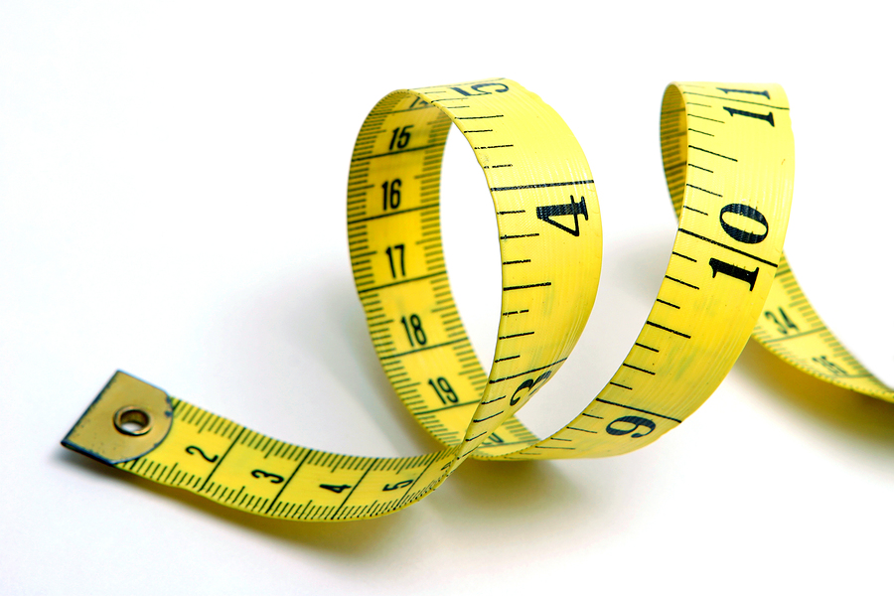**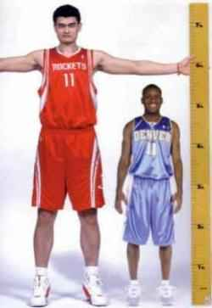Where Do I Stand?**

* icon175x175

How does my height compare with the other AP Stats students in my class? In order to answer this question, Ashmita, a student in 4th hour AP Stats, recorded the heights of everyone in her class. The heights (in inches) were:

68 72 61 62 63 63 64 64 59 62 61 60 65 62 57 77 62 71 65 62 70

1. Create a dotplot to display the class distribution of heights.



2. What is the median height? Describe how you found it.

3. What is *Q*1 and *Q*3? Describe how you found them.

4. Record the following values and then use them to make a boxplot.

Minimum: *Q*1: Median: *Q*3: Maximum:



4. The **interquartile range** (or *IQR*) is defined as *Q*3 − *Q*1. Find the *IQR*. Where do you see the *IQR* in the boxplot?

5. An **outlier** is a data value that is way too small or way too big (using the rules below). Are there any outliers? Show your work.

Way too small < 

Way too big > 

6. Ashmita is 63 inches tall. How does her height compare with the other AP Stats students in her class?

Describing Quantitative Data

Important Ideas:

Check Your Understanding:

Mr. Wilcox is a huge fan of University of Michigan football. His favorite season was the 1997 season (a perfect season!). Here is a back-to-back stemplot of the points scored by the 1997 University of Michigan football team and the archrival Michigan State University football team. Write a few sentences comparing the distributions.

