Is it smart to foul at the end of the game?
In the 2005 Conference USA basketball tournament, Memphis trailed Louisville by two points. At the buzzer, Memphis’s Darius Washington attempted a 3-pointer; he missed but was fouled, and went to the line for three free throws. Each made free throw is worth 1 point. Was it smart to foul?

- What are all the possible ways the shots could fall (e.g. make-miss-miss, etc.)?

- Darius Washington was a 72% free-throw shooter. Find the probability that Memphis will win, lose or go to overtime. When you have found the probabilities put them in the table in #3.
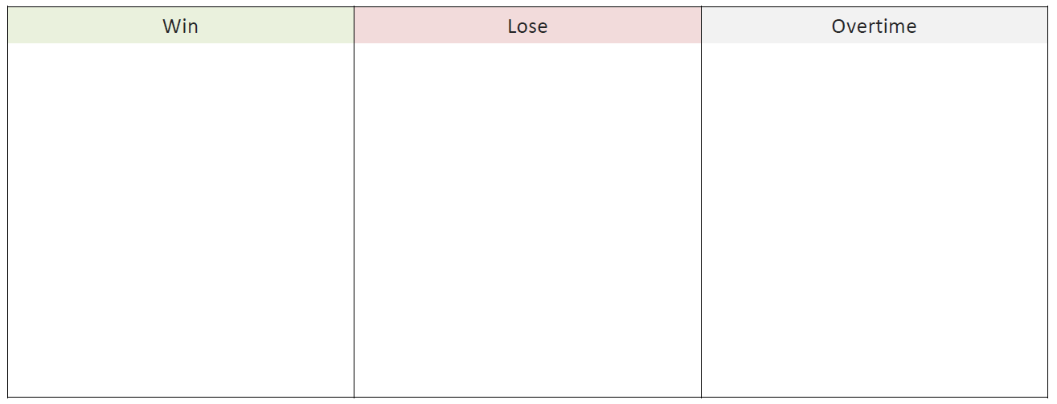

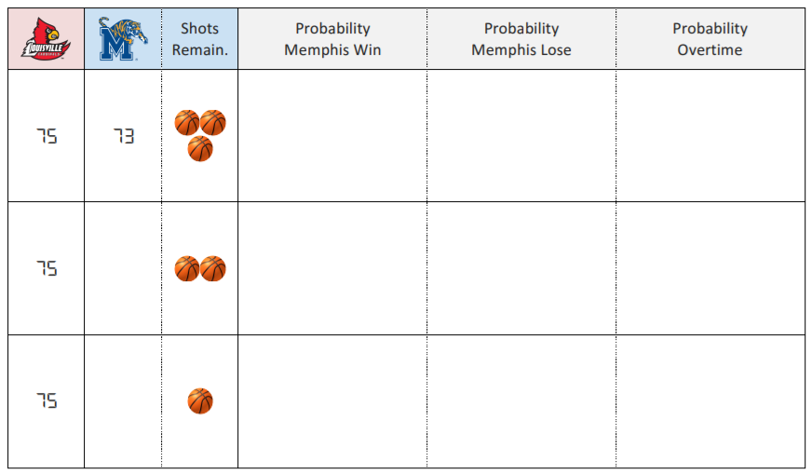
- Prior to watching each shot, calculate the probability that Memphis wins the game in regulation, loses the game in regulation, or sends the game into overtime.

- Washington is a 40% 3-point shooter. Do you think Louisville was smart to foul? Why or why not?

Binomial Random Variables
Important ideas:

Check Your Understanding
- For each of the following situations, determine whether or not the given random variable has a binomial distribution. Justify your answer.

- You play a game of Whack-a-Mole. From playing this game in the past, you know that you have an 80% probability of whacking the mole before it drops back into its hole. The moles pop up randomly and your ability to whack any particular mole is not affected by whether or not you whacked the previous mole. There are 20 moles to be whacked during one round of the game. Let X = the number of moles you are able to whack.

- Next you play Skee Ball. You know that you have a 10% probability of getting any given ball in the 10,000-point hole. Let Y = the number of balls you must roll until you get one in the 10,000-point hole.

- Now you play a game called Tsunami Duck Pond. In Tsunami Duck Pond there are 100 ducks that get pummeled by tidal waves. You have to reach your hand into the tsunami and select a duck. If there is a star on the bottom of the duck, you win. The game claims to have 20 ducks with stars among the 100 ducks. After each round you must place the duck back in the tumultuous water. Let W = the number of times you win if you play this game 10 times.

- Explain why W is a binomial random variable.

- Find the probability that you win exactly 3 times.

