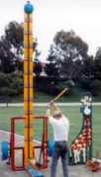
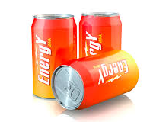
Would you fall for that?

Would you fall for the placebo effect? Watch this video, then complete the rest of the questions.

- Why do you think the people in the video got stronger?

Similar to the video, Mrs. Gallas wants to use a beverage to test the affect that caffeine can have on heart rate. Here is an initial plan:
- measure initial pulse rate
- give each student some caffeine (Coca-Cola)
- wait for a specified time
- measure final pulse rate
- compare final and initial rates

- What are some problems with this plan? What other variables will be sources of variability in pulse rates?

- Go back up to your list in #2 and propose a solution to each problem.

- Design an experiment to test the effect that caffeine has on heart rate.

Designing Experiments
Important Ideas:
Check Your Understanding:

A group of researchers in Africa find a creative way to protect cattle from lion attacks – they paint eyes on the cows’ rears. To determine if this treatment is effective, they randomly assign the cattle to one of three treatments: Eyes on their rear, cross-marks on their rear, or nothing on their rear. After 4 years of roaming the plains, the cows with eyes saw no deaths, the cows with a cross suffered 4 deaths, and the cows with no marks suffered 15 deaths.

- Explain why it was important to have a control group that didn’t get a mark on their rear.

- Suppose the researchers had 1200 cows. Describe how to randomly assign the cows to the treatments.

- What is the purpose of randomly assigning treatments in this context?

- Create an outline showing a completely randomized design for the experiment.

