How good is Mrs. Gallas at free throws?
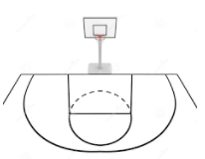
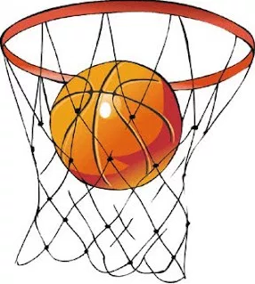
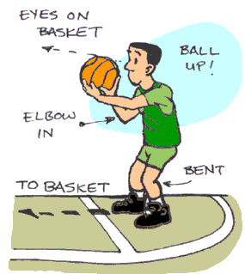

Mrs. Gallas thinks she is a pretty good free throw shooter. How many free throws would you like to see Mrs. Gallas shoot before you could be confident guessing her free throw percentage? We’ll watch Mrs. Gallas shoot free throws, when you are confident make a guess at her free throw percentage.

- As each shot is attempted, keep track of the number of made free throws and the total number of shots attempted in the table below. When you think you know Mrs. Gallas’ true free throw percentage, stop recording the shots.

Shot # | 1 | 2 | 3 | 4 | 5 | 10 | 15 | 20 | 30 | 40 | 50 | 60 | 70 | 80
Result
(Make or Miss)
Proportion of Makes

- What do you think Mrs. Gallas’ true free throw percentage is?

- Sketch the graph displaying the proportion of made free throws.

- How could you make your guess more accurate?

- Mrs. Gallas has a ____% probability of making a free throw. Interpret this probability.

The Idea of Probability
Important ideas:

Check Your Understanding
- Use 4 of the following probabilities to complete the middle column of the table, then give an example of an event may have this probability. Probabilities: 0, 0.001, 0.3, 0.6, 0.99, 1

Explanation | Probability | Example
This outcome is impossible. It can never occur.
This outcome is certain. It will occur on every trial.
This outcome is very unlikely, but it will occur once in a while in a long sequence of trials.
This outcome will occur more often than not, but doesn’t occur almost every time.

- In the Wheel of Fortune, there is a 1/9 = 11.1% probability of spinning “Bankrupt” on any given spin. Interpret the probability.

- In 9 consecutive spins of the Wheel of Fortune, none of the spins land on “Bankrupt”. The next contestant worries that he is more likely to land on Bankrupt now because Bankrupt is due. Explain why this thinking is wrong.

