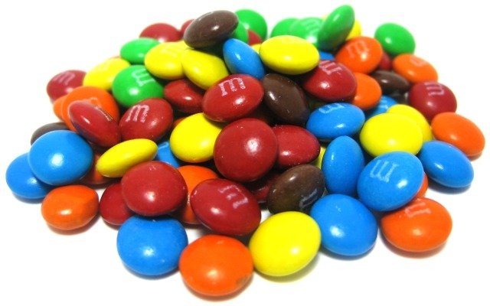
Which color M&M is the most common?
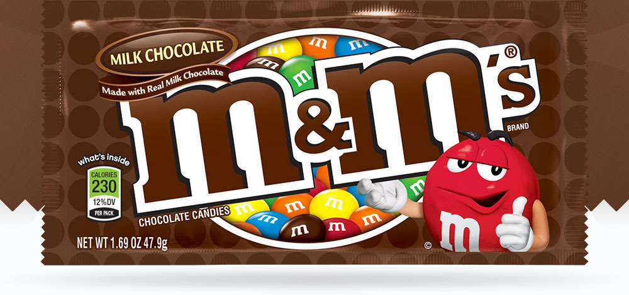

The company that makes milk chocolate M&Ms claims the following distribution:
13% Brown, 14% Yellow, 20% Orange, 16% Green, 24% Blue, and 13% Red. Is this true?

1. Observed values: Brown:_____ Yellow:_____ Orange:_____ Green:_____ Blue:_____ Red:_____

Total number of M&Ms:_______

2. As a class, write down hypotheses for a significance test.

H₀:

H_{a}:

3. Let’s suppose that M&Ms claimed distribution is correct. If they are correct, how many of each color would we expect to get in our sample.

Expected values: Brown:_____ Yellow:_____ Orange:_____ Green:_____ Blue:_____ Red:_____

Use the table to calculate the test statistic.
 | Observed | Expected | (Observed - Expected) | (Observed - Expected)²
Brown
Yellow
Orange
Green
Blue
Red

Add up all the numbers in the last column. This is our test statistic:_________

- What value would we get for the test statistic if our sample was very close to what is expected? Explain.

- What value would we get for the test statistic if our sample was very far from what is expected? Explain.

Chi-Square Test: Goodness of Fit – Day 1
Important ideas:

Check Your Understanding
Carrie made a 6-sided die in her ceramics class and rolled it 90 times to test if each side was equally likely to show up. The table summarizes the outcomes of her 90 rolls.

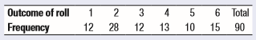

(a) State the hypotheses that Carrie should test.

(b) Calculate the expected count for each of the possible outcomes.

(c) Calculate the value of the chi-square test statistic.

(d) Which degrees of freedom should you use?

(e) Use table C to find the p-value. What conclusion would you make?

