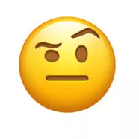
Are Taco Tongue and Evil Eyebrow independent?

Is there an association between the Taco Tongue and the Evil Eyebrow? Below is the data for a random sample of 600 Senior students. Do we have convincing evidence that the ability to do the Taco Tongue and Evil Eyebrow are associated for all Seniors?

- Describe what it means for two events to be independent.

- Calculate the expected counts.

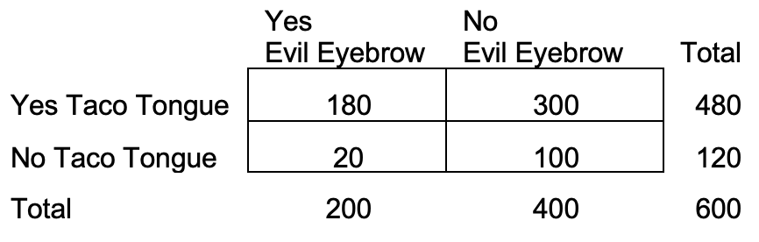
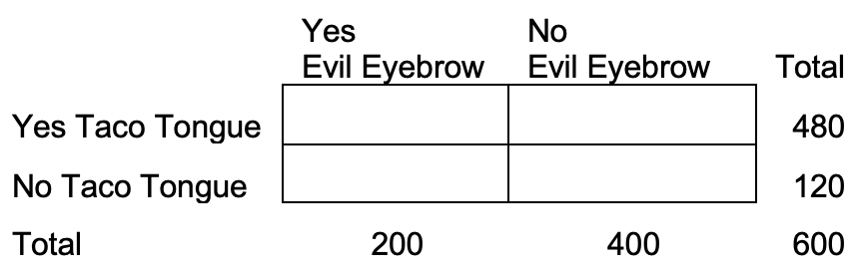
Observed: Expected:

- Do the data provide significant evidence that there is an association between the ability to Taco Tongue and Evil Eyebrow for all Seniors? Use

STATE: Hypotheses: Significance level:

PLAN: Name of procedure: chi-square test for independence

Check conditions:

DO: Specific Formula:

Work: Picture:

Test statistic:

P-value:

CONCLUDE:

Chi-Square Test for Independence
Important ideas:

Check Your Understanding
For each of the following situations decide what type of chi square test is appropriate. Explain.

- A random sample of 200 students was asked to sample a new type of pizza that the school was considering using as a replacement for the current pizza. Each student stated if they were a freshman, sophomore, junior, or senior and also if they liked the new pizza more than the current pizza (or not). The school would like to know if there is a relationship between grade level and pizza opinion.

- Another school is also considering changing their pizza vendor. This school selects separate random samples of 50 freshmen, 50 sophomores, 50 juniors, and 50 seniors. Each student tries the new pizza and states whether they like it more than the current pizza (or not). The school would like to know if the distribution of opinion differs across the grade levels.

- A pizza shop claims that 30% of orders are placed on Fridays, 20% are placed on Saturdays, and 10% of orders are placed on the other days of the week. A global pandemic may have changed this distribution. The manager investigates so he knows how to staff the pizza shop appropriately. He selects a random sample of 300 orders and classifies each one according to the day of the week the order was placed. He wants to know if the distribution of orders is the same as it was before the global pandemic.

