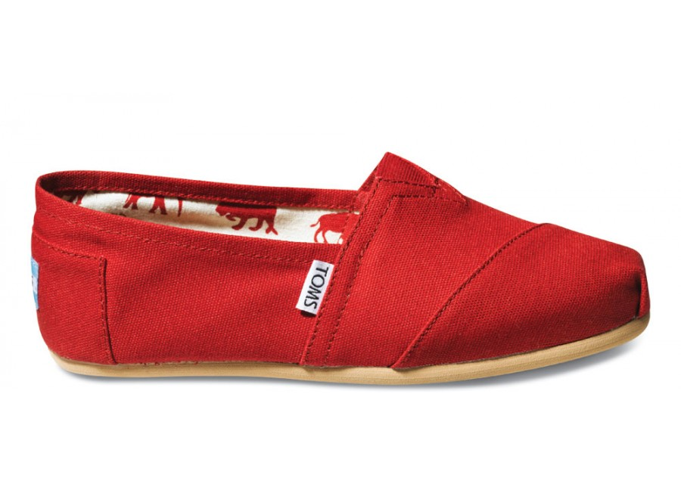
How many pairs of shoes do you own?
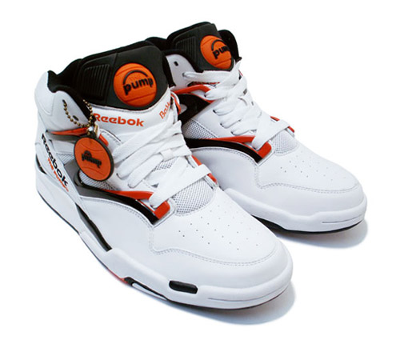
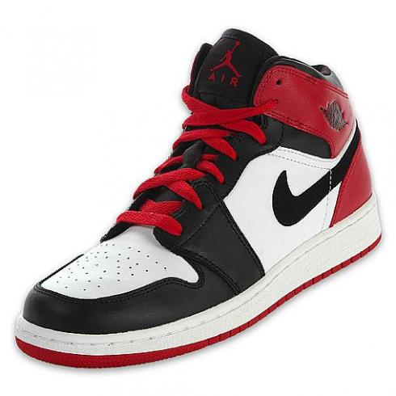

1. How many pairs of shoes do you own? Record your answer on the board.

2. Is “Number of pairs of shoes” a categorical or quantitative variable?

3. Enter the data at www.stapplet.com. Make a dotplot, stemplot, and histogram and sketch each below.

4. List the mean and median of the distribution. Which value do you think is a more appropriate measure of center? Explain.

5. Describe the distribution of the number of pairs of shoes for your class.

Shape:

Outliers:

Center:

Variability (spread):

6. Which of the three types of display do you prefer? Why?

Displaying Quantitative Data
Important Ideas:
Check Your Understanding:
- Mr. Wilcox is a huge fan of University of Michigan football. His favorite season was the 1997 season (a perfect season!). The dotplot shows the number of points scored by the U of M team in the 12 games that season.
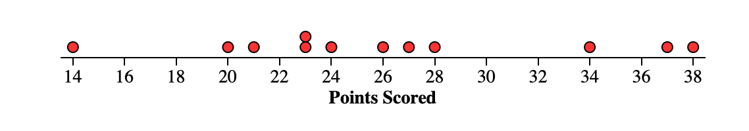
- Use the dotplot to create a stemplot of the distribution.

- Describe the shape of the distribution.

- Are there any potential outliers? Why?

- What measure of center is most appropriate to describe the distribution? Explain.

